The AWA Servicing Set
----------------------oOo---------------------

A suitable servicing set has become definitely the most essential part of the equipment of the Competent Radio Dealer. The Amalgamated Wireless (A/asia.) Limited believe that in producing the “Radiola” Servicing Set, they have presented to the Servicing Dealer the most comprehensive and at the same time, the most keenly priced Radio testing instrument available on the market today.
The A.W.A. “Radiola” Servicing Set is designed primarily to provide in compact form the apparatus necessary for the location of faults in Radio Receivers.

With receivers provided with two or more dials, searching for stations not shown on a Calibration Chart is generally a lengthy and tedious business. The oscillator of the Service Tester provides the means of setting the receiver for these stations, and may, of course, be used to test the receiver when stations have closed down or are out of range.

It may also be used as a wave meter to determine the wave length of stations which cannot be otherwise be identified.

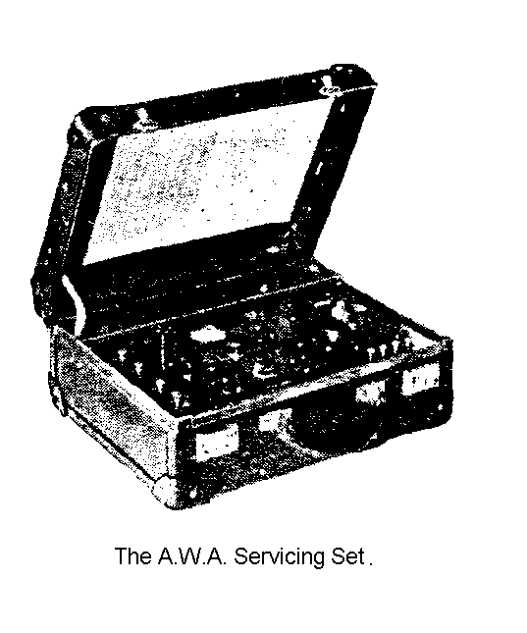

THE SET INCORPORATES

- Testing apparatus for measuring the normal plate current and emission of valves.
- Testing apparatus for checking the continuity of circuits
- Testing apparatus for measuring the voltage of “A”, “B” and “C” batteries; and
- A calibrated modulated oscillator to enable receivers to be tested out without relying on the transmitter stations.

If used carefully, the modulated oscillator should prove a great assistance to the dealer, for it enables preliminary tests to be carried out; and since by tightening the coupling between oscillator and receiver the signals can be made very strong, there can be no doubt as to wether the receiver is sensitive enough to pick up the signal. If when the coupling is very tight the modulated note cannot be picked up on the receiver, it is an indication that there is a fault in the set-up or in the receiver itself.

The AWA Servicing Set
----------------------oOo---------------------

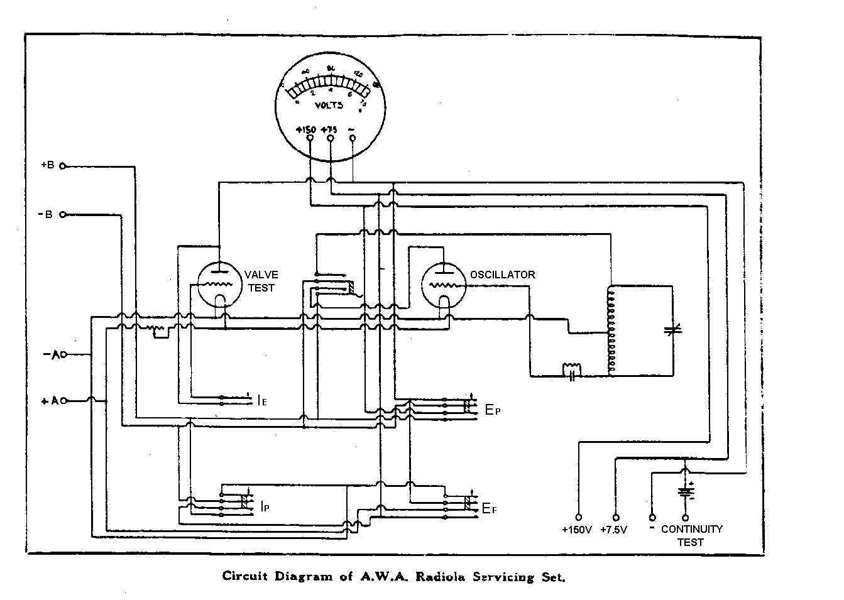

WORKING INSTRUCTIONS

- Turn the switch to the oscillator position.
- Connect a 45V “B” batteryv to the +B and –B terminals.
- Connect a 4V. “A” battery to the +A and –A terminals.
- Plug an A.W.A. 99X valve in the oscillator socket.
- Press Ef and adjust the battery control to 3V. on the meter.
- Press Ep and check the “B” voltage to see that it has full value.
- Set the condenser scale to the reading on the calibration chart in the lid for the wave-length it is desired to test the receiver on.
- Couple the oscillator to the receiver by placing it near the earth lead of the receiver, if an aerial and earth are being used, or near the loop of operated receivers. The coupling coil of the oscillator is in the position shown by the arrow, and the arrow should point towards the earth lead or loop. It is desirable to keep the oscillator some distance away from the receiver, so that it does not couple into the coils of the receiver instead of the loop or earth lead.
- Rotate the selector dials until the high pitched note of the oscillator is heard in the loud-speaker or phones. After a little practice it will be found that once the monitored note of the oscillator is picked up, a better indication of the sensitivity of the receiver can be formed by weakening the coupling; i.e. increasing the distance between oscillator and loop.

The AWA Servicing Set
----------------------oOo---------------------

1  Type | 2  “A” Batt | 3  “B” Batt | 4  Press Ef and adjust rheostat  to | 5  Press Ep  meter readings  should approximate | 6  Press Ip  Meter reading should approximate | 7  Press Ip & Ie  meter reading should not  be less than
MARCONI DE2HF | 3.0 | 42 | 2.0 | 42 | .35 | 1.6
MARCONI DE3 | 4.5 | 42 | 3.0 | 42 | .5 | 1.6
AWA 99 | 4.5 | 42 | 3.0 | 42 | .5 | 1.6
RADIOTRON UX199 | 4.5 | 42 | 3.0 | 42 | .5 | 1.6
RADIOTRON UX120 | 4.5 | 42 | 3.0 | 42 | 1.0 | 2.0
AWA 101X | 6.0 | 24 | 5.0 | 24 | .35 | 4.1
RADIOTRON UX201A | 6.0 | 24 | 5.0 | 24 | .35 | 4.1
RADIOTRON UX240 | 6.0 | 24 | 5.0 | 24 | NIL | 4.1
MARCONI DEL410 | 4.5 | 24 | 3.5 | 24 | .13 | 4.1
MULLARD PM3 | 4.5 | 24 | 3.5 | 24 | .2 | 4.1
PHILIPS A409 | 4.5 | 24 | 3.5 | 24 | .2 | 3.0
PHILIPS A410 | 4.5 | 42 | 3.5 | 42 | .25 | 1.6
MARCONI DEP410 | 4.5 | 24 | 3.5 | 24 | .4 | 4.1
MULLARD PM4 | 4.5 | 24 | 3.5 | 24 | .4 | 4.1
PHILIPS B406 | 4.5 | 24 | 3.5 | 24 | .6 | 4.1

