Portability Kit

This option adds side mounted rails that incorporate a carrying handle and rubber feet for ease in carrying. The versatile side rails allow the unit to be operated vertically in temporary locations or limited space. A front cover is provided to protect the front panel display and connectors during handling.

Cost (US List) $300
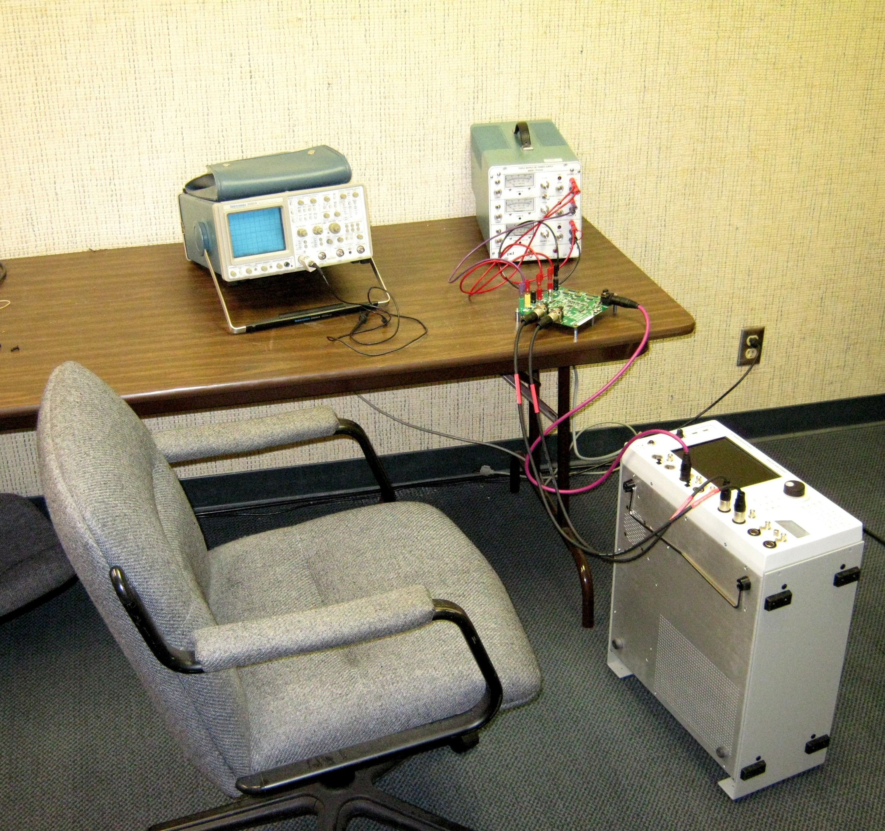

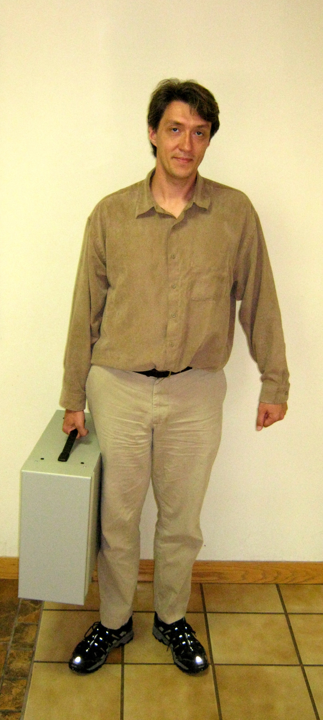

SR1 operated vertically

SR1 with cover

